**Experiment no. 9**

**Name: Sonali Dattatray Kaingade**

**PRN: 21620002**

**Title:** Find correlation between items/entities.

**code:**

#include <iostream>

#include <fstream>

#include <vector>

#include <sstream>

using namespace std;

vector<int> readData(const string &filename)

{

vector<int> data;

fstream file(filename, ios::in);

if (!file.is_open())

{

cerr << "Error in opening input file: " << filename << endl;

exit(1);

}

string line, value;

int lineCount = 0;

while (getline(file, line))

{

if (lineCount > 0)

{

stringstream ss(line);

getline(ss, value, ',');

data.push_back(stoi(value));

}

lineCount++;

}

file.close();

return data;

}

float calculateCorrelationCoefficient(const vector<int> &a, const vector<int> &b)

{

int n = a.size();

int a_plus = 0, b_plus = 0, ab_plus = 0;

for (int i = 0; i < n; i++)

{

a_plus += a[i] == 1 ? 1 : 0;

b_plus += b[i] == 1 ? 1 : 0;

ab_plus += (a[i] == 1 && b[i] == 1) ? 1 : 0;

}

if (a_plus == 0 || b_plus == 0)

{

return 0.0; // To handle cases where division by zero may occur

}

return static_cast<float>(ab_plus) / (a_plus * b_plus);

}

void writeCorrelationCoefficient(const string &filename, float corr_coeff)

{

ofstream file(filename, ios::out);

if (!file.is_open())

{

cerr << "Error in opening output file: " << filename << endl;

exit(1);

}

file << "Pearson Correlation Coefficient"

<< "," << corr_coeff << endl;

file.close();

}

int main()

{

string inputFileName = "correlation_input.csv";

string outputFileName = "correlation_output.csv";

vector<int> a = readData(inputFileName);

vector<int> b = readData(inputFileName);

float corr_coeff = calculateCorrelationCoefficient(a, b);

writeCorrelationCoefficient(outputFileName, corr_coeff);

cout << "Correlation coefficient calculated and saved in '" << outputFileName << "'." << endl;

return 0;

}

**Output:**

**Input.csv:**

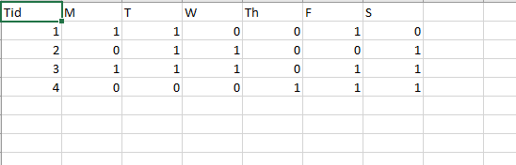

**Output.csv:**

